“Hold-Everything” is for collecting ideas & info
As your project or show slowly starts becoming a reality you’ll be flooded with ideas when you least expect it. The “Hold-Everything” is a simple system to capture at least some of them.
Use these sheets to simply dump information if it comes to you. I recommend spending about an hour just ‘dumping’ all your ideas onto MSWord Document, then printing it out and putting it into a binder with extra, blank sheets available. In a perfect world, I’d try to digitally update the “Hold-Everything” once a week, adding everything you jotted down by hand to the MSWord document until you have systems in place that make it easy to dump thoughts directly into their Usable locations (for example, getting new contact names into MailChimp with appropriate tags).
In reality, you may never have a smooth system for getting thoughts into their Useful location immediately, so the Hold-Everything is always a great thing to have.
- Don’t worry about “filling it in” or getting all your ideas
- Just catch thoughts/ideas/dreams/images if you have them.
- Don’t worry if they’re realistic
- The goal is to have ONLY 1-or-2 places to look when searching for ideas you had or inspiration you need
- You can modify or adapt this document as needed to make it work for YOU

On the following pages you’ll see:

1. Holding (or “Dumping” Locations)
Where to dump ideas, examples & content so you can find them again.

2. Categories of Things to Collect & Dump

If, at any time, you feel overwhelmed ...

Just step back to the simplest form of what you’re doing that you can

Dump Locations
In reality, you won’t always have this page and pen beside you, and even if you do, you’ll want to store these pages somewhere safer than loose on your music-stand. So, realistically you’ll want several places, so you can dump from where you are:
- Onto paper (into a notebook which might contain these pages & others)
- Onto your computer (into a set of files and folders, and/or into “Evernote”)
- Online (into Pinterest, Bookmarks or both)

Some of my personal Dumping Grounds:
- An Image folder on my computer: one folder where I put all photos I might want to use
- A Project folder for each show, including subfolders for different kinds of content (documents, images, video, audio)
- “Bookmarks” in my browser to bookmark pages with ideas or examples I want to remember
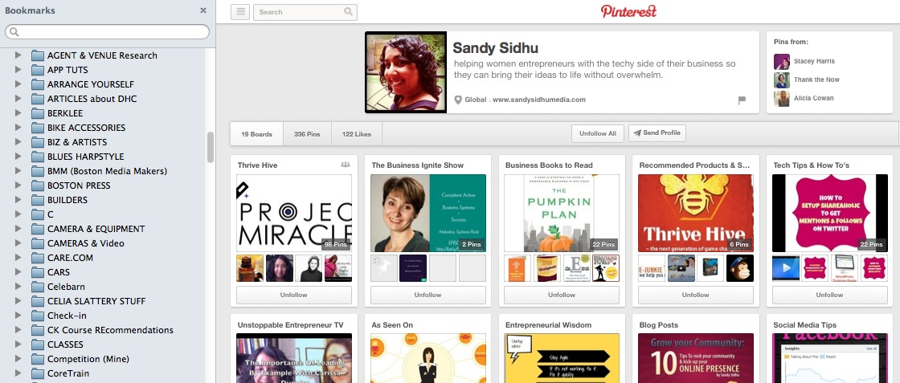
- Pinterest: I’ve just started using Pinterest Boards to store/organize images & links to web pages that are relevant or that I want to access. The advantages are that you can also add comments (to help you remember why you liked this page), and I think you can choose specific images on that page (rather than choosing the whole page).
Another advantage is that you can easily share these ideas with other people working on the team (like someone helping you with costumes, lighting, posters, etc.) and you can upload pictures directly from your computer.
My bookmark folders on my browser (Firefox)
My friend Sandy’s “Pinterest” boards where she keeps images & links to web pages organized by categories that are useful to her

- Evernote: I’ve tried using Evernote, and haven’t been successful sticking with it, but one of my best buddies swears by it for doing everything from clipping images and text from websites to recording our Skype meetings.

What TYPES of things to Collect & Dump

1. Ideas:
Ideas are things you might want to put in your show.
For Example: Snippets of text you think of, sketches of costume ideas, lighting changes, people you want to contact about the show including media personalities

2. Examples:
“Examples” are ways of doing things you see other people doing and that you like and might want to emulate.
For Example: Webpages you like, posters, press releases, songs you like the sound or structure of – anything you will have to create for your show, it’s great to have examples you’ve seen that you like (it’s like having an example of the color of paint you want for a room on a swatch sheet so you can show a paint company)

3. Usable Content:
Content is the text & media you’ll actually USE
For Example: Images of you that you like and might want to put on a poster, an exciting description of your show you’ve written, actual songs you want to play

“Ideas” versus “Usable Content”
Of course, there’s always some overlap, but basically “ideas” are the raw materials, and the “content” are things that exist in ‘workable’ or sharable form. – and both are valuable!
Like, you might write down ‘ideas’ of sentences or phrases you think would explain your show (for your bio or event-description). Or you might collect a bunch of photos of you that might work in a poster. Or you might have ideas for song lyrics. Those are ideas.
Once you create a usable show description, or you decide on a photo for your event page, or you create a poster, or you have a page with the lyrics for your song – those are “usable content.”
You might also think of it as “Sharable Content” but I don’t call it that because to technically make it ‘sharable’ on the web, you usually have to put it into a format that allows you to click a ‘share’ button

5 Mediums of Things to Collect
These are the things I generally find myself collecting, and I often find it helpful to think about what MEDIUM each, first, rather than where they ‘fit’ content-wise.
By that I mean that, in general (but not always!), I like to collect all images together in one big image bin, all videos in another bin, all audio in another bin, etc. – and then separate those bins into sub-bins that are named by event, content or subject – rather than collecting all the elements (images, videos, audio, text) for a specific event or subject.

- WORDS includes things you’ll say or sing, or ideas like blurbs for Facebook event pages, bits of script, song lyrics or titles
- MEDIA
  - Images include images you see and like, images you create (like mini-posters), images of you that you want to use somehow in the project
  - Videos include work-videos you take during rehearsal, so you can give yourself feedback; videos you send to me to show me your work; promotional videos of you in performance-or-rehearsal to put on YouTube to promote the show and talking-head videos to talk to your audience/fans about the show you’re creating
  - Audio includes work-audio you record and listen to of your show; promotional audio you post onto Soundcloud, offer to the media during interviews or offer to potential fans in exchange for email addressses
- WEB PAGES include examples of pages you want to use for inspiration or direction, web-pages you create and need to quickly provide the links to so other people can see them, web-pages of places you’ll want to post your work (like blogs and listings pages)
- PEOPLE including team members, audience & broadcasters
- ‘THINGS’ actual physical things (instruments, props, costumes)
Where Do I Collect It?
In addition to this physical Hold-Everything, I like to set up at least one computer or online holding-place where I can throw ideas, images, URLs when I get them, so I can find them when you want to organize or use them. I also use “Bookmarks” to create bins for webpages. Some people use “Evernote” for that kind of a dump – some people use Pinterest. If you already have some kind of system for this, and you basically like it, then use what you’re already used to.
The goal is to make it EASY for you collect all your ideas into one place. Set up 2 or 3 places/ways to collect ideas because these dump-pages will help you start, but you may not always have them handy.
What are Ideas? “Ideas” are everything from songs you’d like to play, to ideas about how to play them, people you want to invite to your show, what color to wear, a title idea the show – or anything else that you can write down in words.

IMAGE-Collecting:
Start collecting images – images of you, images you like the way they look, images of things you want to do.
I collect mine in these places:
- A “Camera Download” folder on my computer (which automatically downloads from my phone)
- An “Images Dump” folder for images I download or create
- An organized folder of image bins when photographers send me a series of photos they’ve taken of a show
- iPhoto
- On Pinterest Boards

What kind of images do you love?

What kind will be useful on your website or in your press kit?

Where will you keep them?

AUDIO/VIDEO-Collecting:
You should also start collecting audio & video ideas/examples. I collect them in three places:
- iTunes
- iPhoto
- A computer folder
- A bookmarks (if they’re on the web) or iTunes.
.

PEOPLE / CONTACTS:
Contacts are the people you’ll put on your “contacts” list. They may be clients, audience members, people who’ll hire you, people who’ll help you do you show, coaches, students, colleagues, and many more.

It’s very helpful when you ‘tag’ them so you can connect with specific people about specific things.

Some people will have more than one ‘tag’ if you might communicate to them about more than one thing. For example, people who hire you, and who you might contact about an opening in your schedule – will also be people you want to invite to you programs.

But before worrying about how many different tags each people needs, just start collecting these people.

Audience | Contacts / People
Anyone you want to invite to your show, starting with family, and even ridiculous celebrities you’d want to come to your show. Also include people who might hire you in the future.

Presenters/Venues / Agents | Contacts / People
Anyone you might like to have hire you, and anyplace you might want to play or anyone including your livingroom, YouStream, your favorite local theater, Broadway. Remember, this page is just a dumping ground.

Team | Contacts / People
Anybody who has skills that might need for a show including: lighting designer, dogsbody (someone who loves you and would be happy to do gruntwork), publicist, graphic designer – these can be specific people you know, people you’ve always wanted to work with but know you can’t afford, or types of people – either in terms of their type of skill or simply the type of people whose character you like to be around.

CONTENT / CREATIVE IDEAS

Titles
Any time you think of a cool title for a show, a song, or anything else, jot it down.

Repertoire
Any thoughts you have about pieces you want to play (later you’ll get a Repertoire sheet, but just write any ideas here for now and any ideas ‘about’ the pieces that you have)

Stories
Stories you might want to tell from your life, or things you want to say to the audience because they’re important to you or shine a light on why you do what you do, or because they’re funny, or illustrate the life of a harpist.

Schtick
Anything silly, physical or non-musical that’s an idea about how you might play with the content

PRODUCTION

Staging/Lighting/Props
Any ideas about staging, lighting, props. If you ‘see’ something in your mind, just try to describe it. If you see it on the web, either get a screenshot or bookmark the page. If you see it in a magazine, take a photo of it. If you find a method that works best for you (like snapping a photo with your phone instead of bookmarking, go with the method that’s most comfortable for you)

Costuming
Any ideas about what you love wearing, or what you love seeing others wear. This can be as simple as a word like “messy” or “flowy” or “superhero” or a phrase like “athletic, but flowy” or “I need to feel safe, like it won’t fall off, but I like it to LOOK like it might” or “I love how red high-heels look but I can’t wear them and feel comfortable except when I’m sitting down” – also any images (as above)

PROMOTION

Blurbs & Bios
Phrases that come to you, or that people say to you about you, or that you hear about others and like the sound of; even just words that you like or wish people used to describe you.

Posters/Flyers
Any ideas you have about flyers & posters, and especially examples of other posters or flyers you see that you like

Totally Random Ideas

