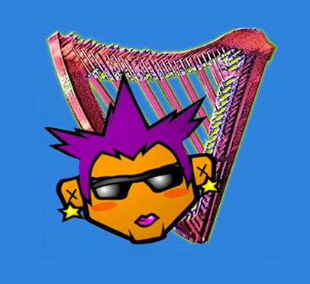­

## **To change this image right-click it or control-click-it and select “Change Picture”**

## **To change the frame shape choose “quick styles’ under “Shape Format’ and/or double click the image to hopefully get the Shape Format menu.**

## **I don’t know why – but sometimes the photo prints and sometimes it doesn’t. Sometimes the choice of photo frame seems to affect that and sometimes it doesn’t. This was the only frame I could get it to print right now. I hate MSWord.**

You can change any part of this, or use your own template, but notice all the ELEMENTS of this template, and make sure you include them in your poster

NOTE – The poster background APPEARS much lighter than it prints

## Imagine a concert experience that explores the wild side of the harp in every form – from savage beasts to a wilderness soundscape.

**The Harp Goes Wild**

## Wild-eyed wonderharp from Beethoven to Jazz with special guests

## Bubba Bugoidis, Trombone ~ Stella Castelluci, Interpretive Dance

## 

Blevans Music Presents Harpist & Vocalist

**Anna Specalli**

## “Anna makes music FUN!” Quotable Person (or your tagline)

# **Venue ~ City ~ Date/Time**

How and where to get tickets & how much they cost

and other cool info about parking, transportation and how great this venue is

**ArtistWebsiteOrURLforTix.com**